Automatic Number Plate Recognition and Recording System using k-NN
Mr. M A Muneer¹, Ashwini Tarun², Thumar Jankiben Narshibhai³
muneer.it@jbiet.edu.in¹, ³tarunaswini23@gmail.com², jankipatel4566@gmail.com³
Department of Information Technology, J. B. Institute of Engineering and Technology, Hyderabad

Abstract— Transport surveillance and recording each vehicle's information in a journal are both exceedingly labour-intensive tasks. A " Detection and recording of number plates automatically " can be used to resolve this issue. Using the k-NN model, we have suggested a method in this research study enabling the system to be able to detect the number plate (a machine learning technique used for classification), and information about the car, such as the number plate, a picture of the vehicle, the time, etc., is stored in the database. The k-NN model is trained using several alphabetic and numeric styles to get a high level of accuracy. Additionally, we used a separate dataset of cars in our research work to validate the findings.

Keywords— Number Plate Detection, Optical Character Recognition, k-Nearest Neighbour model, Character Classification, Gaussian filter, Machine Learning
- Introduction

A metal or plastic plate used for official identifying purposes that is fastened to a car, truck, or trailer is called a number plate. Road vehicles, including cars, trucks, and motorcycles, must have number plates in all countries.. Depending on the jurisdiction, they might also be necessary for other types of vehicles like bicycles, boats, or tractors. There are frequently legal restrictions on how number plates should look. For instance, limitations on plate design, registration number positioning, and plate colour. In some jurisdictions, number plates are given to a specific vehicle and remain there for the duration of the vehicle. The number plate must be returned if the car is disassembled or exported to another nation.
“The subject of study known as intelligent transport systems (ITS) is exceedingly diverse and has attracted the attention of many academics” [1] . “The use of information and communication technologies to improve the efficiency of transportation systems is discussed. As a result, both commuters and drivers can navigate the roadways with increased convenience and mobility. In addition to parking management systems, electronic toll collection systems, inter-vehicle communications, and road surveillance systems, ITS can have a wide range of applications thanks to the development of fast and reliable data transmission and algorithms for the automation of manual processes. Because of the growth and improvements in the field of computer vision and image processing, road surveillance systems were one of the applications mentioned that particularly intrigued the researchers”[2].
“In recent studies, cameras have been erected and placed in strategic locations to catch the roads that need to be monitored. Then, from the video feeds, real-time traffic data analysis is done. Vehicle detection, tracking, and identification are frequently included of road surveillance systems. Vehicle recognition is the process of analysing a vehicle's attributes in order to determine who owns it. One such technique is the recognition of number plates, which can be done using algorithms for optical character recognition. Using algorithms to recognise number plates can assist police catch those who break traffic laws, identify the owner of the car, and prosecute them for their crimes”[3].
Many scholars have used OCR, k-NN, algorithms to work on character recognition. A couple of papers are "Handwritten Character Recognition Using K-NN Classification Algorithm" by Siddhartha Roy and M. Saravanan and "Character Recognition Using KNN Algorithm" by Sai Jahnavi Bachu. They have demonstrated that utilising these algorithms, we can detect characters with a high degree of accuracy.
- Existing System
  - Number Plate Recognition Using OCR(Optical Character Recognition)

Number Plate Recognition using OCR is an existing system. In this existing system an image is sent, the number plate recognition system will attempt to locate the number plate before sending it to the OCR for character recognition. The number plate area is once again searched from the image if OCR cannot read the characters from it.
It has a few drawbacks, including:
- It's not always of excellent quality.
- Both expensive and time-consuming.
- Occasionally incorrect.
- Being unable to recognize some languages.
- Inaccuracy with damaged texts.
- Literature Survey

Character recognition has existed in systems prior to the development of computers, so it is not a recent issue. The early OCR systems weren't computers; instead, they were mechanical machines capable of character recognition, but they were extremely slow and inaccurate. The most early example of contemporary OCR can be found in M. Sheppard's reading and robot GISMO, which was created in 1951. GISMO has the ability to read words on a printed page one by one as well as musical symbols. Only few characters, nevertheless, can be recognised. A typewritten page can also be copied by the machine. In 1954, J. Rainbow created a machine that can read one capital typewritten English character each minute.
Due to errors and a low recognition rate, the early OCR systems were disregarded. As a result, little research was done on the subject throughout the 1960s and 1970s. Governmental organisations and major enterprises, including banks, newspapers, airlines, and others, have undergone developments. It was thought that there should be standardised OCR fonts to simplify the work of recognition for OCR due to the difficulties involved with it.
“Then, in 1970, ANSI and EMCA established OCRA and OCRB, which had comparably respectable recognition rates. OCR has been the subject of extensive investigation during the last 30 years. This has prompted the development of omni-font, multi-lingual, handwritten, and document image analysis (DIA) OCRs. Despite all of this research, a machine's reading comprehension still lags far below that of a human. The goal of the present OCR research is to increase the accuracy and speed of OCR for documents with a variety of styles that are printed or produced in unrestricted situations. No open source or paid software has ever been made accessible for difficult languages like Urdu, Sindhi, etc”[4].
Claudiu was explored utilising a straightforward pre-processing of the training data that produced experts with less correlated mistakes than those of various networks trained on the same data or bootstrapped data. Our committee-based classifiers were the first to perform as well as humans when classifying isolated handwritten characters.
- System Architecture

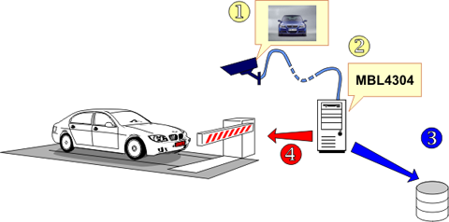
Figure 1: System Architecture

The system architecture provides a brief overview of the process. The system automatically takes a picture and sends it to the "Number Plate Recognition System" whenever a car approaches the barrier. The computer will now take the text off the number plate and enter it into the database along with other fields like the time and date.

- Algorithm
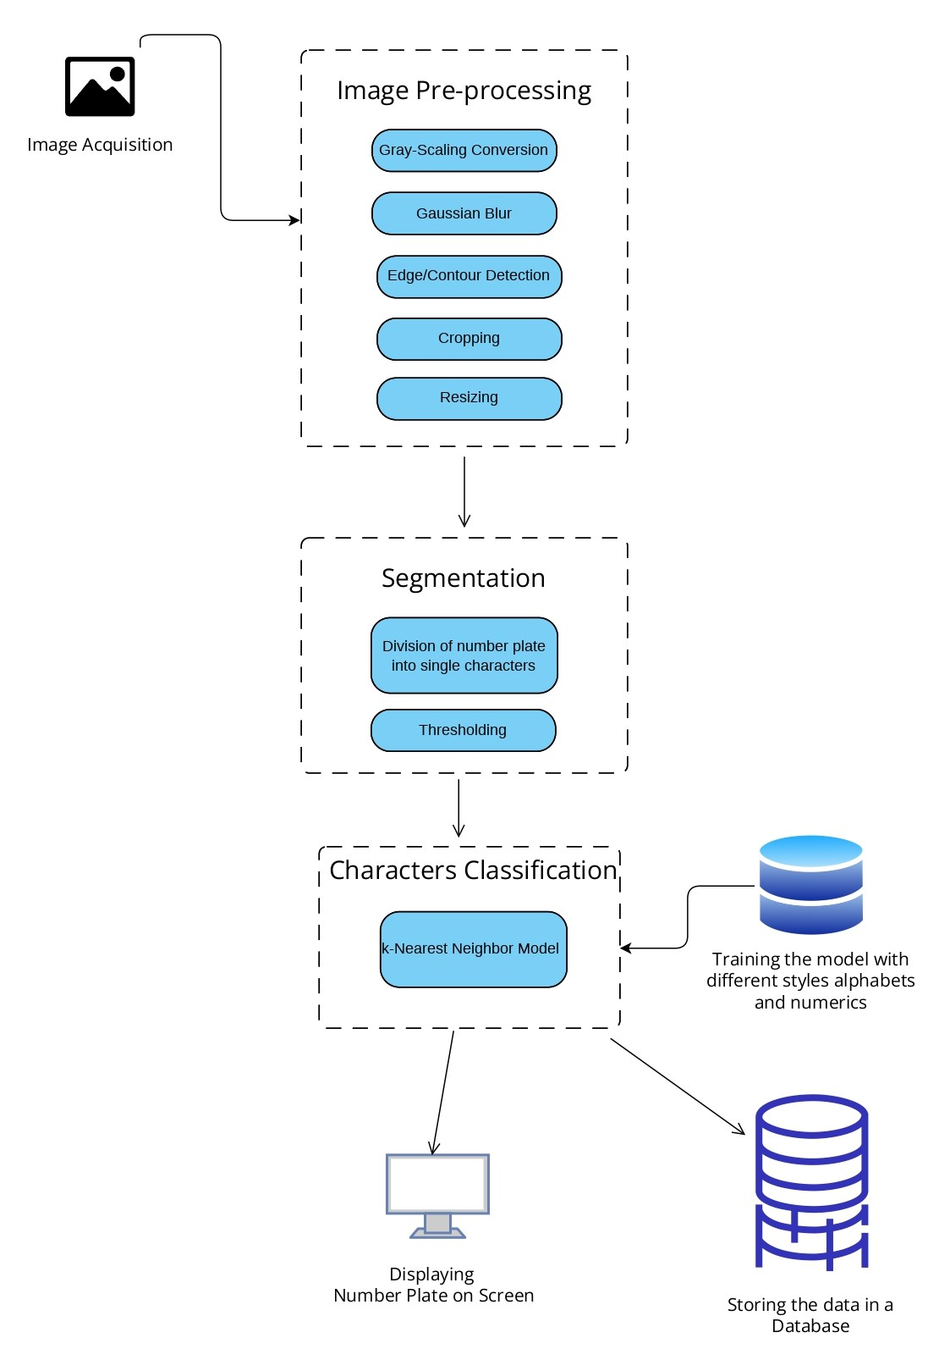
Figure 2: Flow Diagram of the Proposed Algorithm

The system that we suggest is called "System for Automatically Detecting and Recording Number Plates". This involves several steps,

  - Image Acquisition

The image is represented in a 2-dimensional function, with the parameters x and y referred to as spatial coordinates. The amplitude of Function F is the intensity of a picture at a certain position. A digital image is one that has a finite x, y, and amplitude. Pixels are the portions of a picture that include information about colour and intensity.

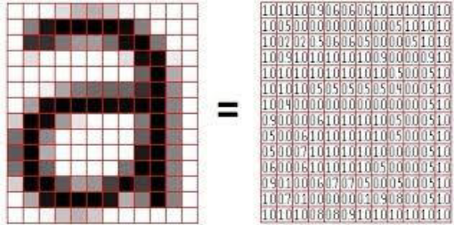

Figure 3: An image in a matrices form

  - Image Pre-Processing

- Gray Scale Image

First the image has to be converted into a Grayscale image. A Grayscale images are created by storing the intensity of light in each pixel. It appears to be a black-and-white picture. It ranges in value from dark black to dazzling white..

- Noise Reduction

We can use a Gaussian filter for the noise reduction. Just consider that if we capture an image in less light, the image may have some noise in it. Here, we can use a Gaussian filter or blur to reduce these noises. In the case of texts, this will make the characters appear more clearly..

- Edge Detection

The way in which we can find the areas in a digital image that have sharp changes in brightness is called edge detection. The edges of an image are places where the brightness of the picture may vary sharply. The Roberts detection of edges and Sobel detection of edges are the two major ways to perform edge detection in the image processing phase..

- Cropping of Image

Here, the image is cropped to the number plate detection based on edge detection. The remaining sections are eliminated because they are superfluous.

- Resizing of the image

Because the image was taken at a variety of distances, each cropped image has a different size. The images should, however, be input in the same size. So, all of the cropped images should be resized to the same size.

  - Segmentation

The number plate is separated into individual characters in this stage, which will be useful in subsequent steps. This is important because image segmentation, which divides an image into smaller sets called "image segments" and reduces the complexity of the image while enabling further processing of each segment, is a technique..

The segmentation stage of the image recognition system is crucial because it will extract the features for additional processing, like recognition, the segmentation stage of the image recognition system is essential. Images can be segmented for the purpose of classifying image pixels.

  - Character Classification

K-Nearest Neighbour is a good supervised learning technique in machine learning. Based on the idea that the new data point and old instance point can be comparable, the K-NN algorithm places a new data point in the categories that are similar to the already trained and loaded categories. When a new data point is introduced, the K-NN algorithm classifies it and saves it all depending on how similar it is to the current data. This indicates that we can quickly and accurately classify new data points in the provided categories using K-NN.

Even though the K-NN approach may be used to solve both classification and regression problems, it is often applied to classification tasks. Since K-NN is a non-parametric method, the underlying data is not taken into account..

The K-NN algorithm is also known as the "lazy learner" algorithm because it stores the training dataset before performing an action on it at the time of classification instead of immediately learning from it. The K-NN algorithm simply stores the dataset during the training phase and uses it to classify new data points into a category that is very similar to the training dataset..

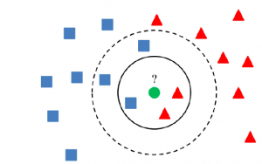

Figure 4: k-NN Algorithm

Choose the neighbour with the number K. Determine the Euclidean distance between K neighbours. Pick the K closest neighbours based on the Euclidean distance estimate.

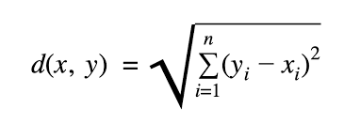

Among these k neighbours, total the number of data points in each category. Assign the new data points to the category where the neighbour count is at its highest. Our model is complete.

- Conclusion

In this study, the k-nearest neighbour algorithm was employed to identify number plates. The number plate detection accuracy of the system is 82.75%. It can be said that the real-time k-NN plate recognition system worked well.

By positioning the camera to capture the ideal body and using neural networks in two layers, this accuracy can be significantly increased. Alternatively, a hybrid classifier can be created by combining different classifiers and training it on a wider variety of dataset.
References
- M. S. Uddin, A. K. Das and M. A. Taleb, "Real-time Area Based
Traffic Density Estimation by Image Processing for Traffic
Signal Control System: Bangladesh Perspective," in 2nd Int'l Conf. on Electrical Engineering and Information & Communication Technology, Dhaka, 2015.
- B. F. Momin and T. M. Mujawar, "Vehicle detection and Attribute based search of vehicles in video surveillance system," in International Conference on Circuit, Power and Computing Technologies, Nagercoil, 2015.
- A. R. F. Quiros, A. Abad, A. C. P. Uy, A. Bandala, R. A. Bedruz, E. Sybingco and E. P. Dadios, "Automated Traffic Violation Apprehension System Using Genetic Algorithm and Artificial Neural Network," in TENCON 2016 - 2016 IEEE Region 10 Conference, Singapore, 2016.
- Sai Jahnavi Bachu, B. Tech in K L University, "Character Recognition using KNN Algorithm" International Journal of Science and Research (IJSR),ISSN: 2319-7064,SJIF (2019): 7.583
- M. Kumar, M. K. Jindal and R. K. Sharma, "k-nearest neighbour based offline handwritten Gurmukhi character recognition," in ernational Conference on Image Information Processing,Himachal Pradesh, 2011.
- Qiu D, Lu J, Sun X and Jiang J 2010 Application of graphic minimal covering algorithm in the distribution of surveillance cameras in small and medium-sized city road networks 2010 International Conference On Computer Design and Applications vol 1 pp V1-200-V1-203
- Islam R, Sharif K F and Biswas S 2015 Automatic vehicle number plate recognition using structured elements 2015 IEEE Conference on Systems, Process and Control (ICSPC) pp 44-48
- Pradeepa, J., E. Srinivasana & S. Himavathib. Neural Network based Recognition System Integrating Feature Extraction and Classification for English Handwritten. International Journal of Engineering 25: 99–106(2012).
- Y. LeCun, et al., Comparison of learning algorithms for handwritten digit recognition, in: F. Fogelman-Souli e, P. Gallinari (Eds.), Proceedings of the International Conference on Artificial Neural Networks, Nanterre, France, 1995, pp. 53–60.
- Object Recognition Using K-Nearest Neighbor Supported By Eigen Value Generated From the Features of an Image, Dr. R.Muralidharan
- “Handwritten Digit Recognition Using K-Nearest Neighbour Classifier”: U Ravi Babu, Dr. Y Venkateswarlu, Aneel Kumar Chintha.
- Kulkarni P, Khatri A, Banga P and Shah K 2009 Automatic number plate recognition (anpr) system for indian conditions 2009 19th International Conference Radioelektronika pp 111-114

